Gacasa, Ymanuel Josh R.

The data we used is table 10.6

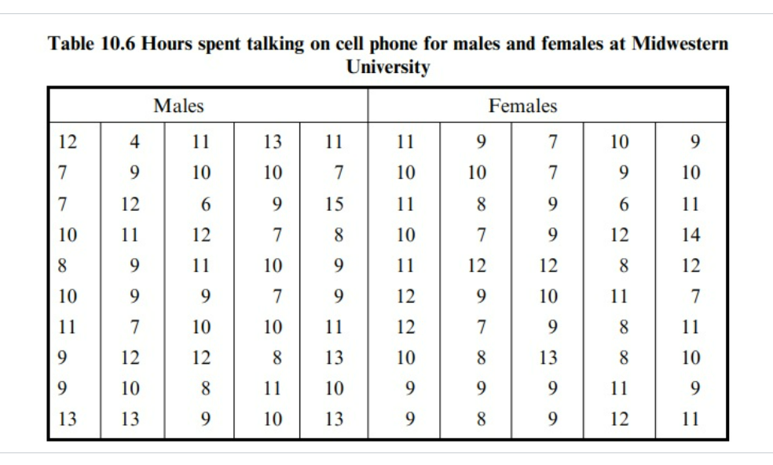

Hypotheses:

Null hypothesis: There is no significant difference in the meantime spent on cell phones between male and female college students. $μmale=μfemale$

Alternative hypothesis: There is a significant difference in the meantime spent on cell phones between male and female college students. $μmale≠μfemale$

Since the p-value of my data is greater than 0.05 this will fail to reject the null hypothesis  
  
If the p-value is greater than 0.05: Fail to reject the null hypothesis. There is no significant difference in the meantime spent on cell phones between male and female college students.

Rationale:

Population parameters

$$μmale:Population mean time spent on cell phones by male college students.$$

$$μfemale:Population mean time spent on cell phones by female college students.$$

Shapiro-Wilk Test for Male Data: The data for males is normally distributed.

Shapiro-Wilk Test for Female Data: The data for females is normally distributed. With a p-value of 0.14 > 0.05

Levene's Test: The variances of the two groups are equal. With a p-value of 0.14 > 0.05

Do you see a need for larger sample sizes and more testing with the time spent on cell phones?

the decision to pursue larger sample sizes and additional testing depends on a nuanced evaluation of statistical and practical considerations. It's essential to balance statistical rigor with the feasibility and goals of the research project.